Barnardo’s Beacon Project
Request For Support

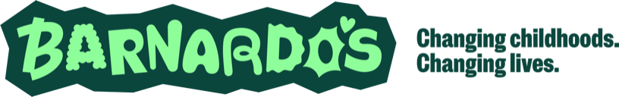
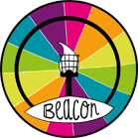
The Beacon Project is designed to help professionals build knowledge and understanding when supporting children/young people who have experienced/disclosed “child sexual abuse”. For clarity:
Child Sexual Abuse (CSA) involves forcing or persuading a child or young person to take part in sexual activities, whether or not the child is aware of what is happening. This includes acts that involve physical contact such as assault by penetration, non-penetrative acts (eg. masturbation, kissing, rubbing and touching).
It also includes non-contact: involving children in looking at (or making) sexual images, watching sexual acts, encouraging children to behave in sexually inappropriate ways, grooming a child (including via the internet).
Our service offers are free of charge and are centred on being trauma informed
and young person centred.

Section 1 | Informed Consent  We cannot accept enquiries relating to specific young people without the young person or their parents consent to their information being shared with us.  I confirm that I have the child, young person and parent or carers (where applicable) permission to share data with Barnardo’s.
Full name:

Signature:

Role/job title:

Today’s date:

Name and date of person giving consent:

Section 2 | Organisation details  Where possible we will contact you via email or telephone within 7 working days.
Contact name:

Role/job title:

Agency/Organisation:

Organisation address:

Contact telephone number:

Contact email address:

Section 3 | Child/young person’s details
Child/young person’s name: |  | Date of  Birth: |  | D | D | M |  | M | Y | Y | Y | Y
Child/young person’s gender identity:

Child/young person’s pronouns:

Child/young person’s age:

Child/young person’s ethnicity:

Child/young person’s address: |  |  | Postcode:
Please detail if child/young person requires any additional support:

Section 4 | Professional involved  If you are not working with a specific young person/people please move on to section 5.
Is the child/young person open to Children’s Services? | Yes / No  (Please delete as applicable) | If yes, please provide name and contact details of Social Worker:
Please indicate the support being offered by Childrens Services: | Please tick ✓ as appropriate:
 | CIN (Child in Need)
 | CP (Child Protection)
 | Under Assessment (UA)
 | CLA (Child Looked After)
 | Early Help

Section 5 | Concerns and support required  If you are working with specific child/children please provide details of presenting concerns – we will be unable to progress your enquiry if this information is not provided. If not continue to section 7
Date of disclosure:

Have the allegations been investigated by Police and Children’s Services: | Yes / No (please delete as applicable)  If yes, please provide details below:
Date allegations reported to Police:

Name of Investigating Officer:

Is the investigation ongoing: | Yes / No (please delete as applicable)
Details of concerns:

Please specify the child / young person’s current support needs:

Section 6 |  | Support required  Please note some of the options below are things we do not directly offer but can support you to access
Please see “What we offer” page on our website for more information |  | Please tick ✓ as appropriate:
 |  | Training for individuals and organisation
 |  | Consultancy
 |  | Sign posting (no direct delivery services)

Section 7 |  |  |  | How did you hear about us? Please tick ✓ as appropriate:
Online search |  | Sign  posting |  |  |  | Meeting |  | Recommendation |  | Other
If other, please specify:

Please return completed form to:

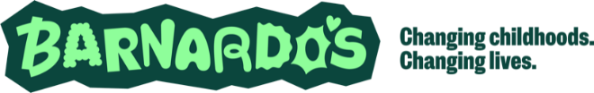

Beacon Project
Barnardo’s
Brooklands
Great Cornbow
Halesowen
West Midlands
B63 3AB

If you have any questions regarding any section of this form, please contact us on:

01384 411722

Our office hours are Monday to Thursday 9:00am to 5:00pm and Friday 9:00am to 4:30pm

Website: www.barnardosbeacon.org.uk

Email: barnardosbeacon@barnardos.org.uk

What happens next?

- Returned and completed enquiry forms will be received by Barnardo’s Beacon Team; forms received by email will receive an automated reply

- Your enquiry will be reviewed and discussed at a weekly triage meeting

- The Beacon team will aim to reply to your enquiry within 7 working days from receipt

